

American International University-Bangladesh (AIUB)  
Department of Computer Science  
Faculty of Science &Technology (FST)  
Fall 2023

Section: E  
Group No: 10

Software Quality Assurance and Testing

E-Toll Collection System

A Report Submitted

By

|  |  |  |
| --- | --- | --- |
| SN | Student Name | Student ID |
| 1 | Dihan, MD. Rafee-uzzaman | 19-40320-1 |
| 2 | Asha Islam | 19-41222-2 |
| 3 | Billah, Bayezid | 20-42117-1 |
| 4 | Md Rayhan Talukder | 20-43764-2 |

Under the supervision of  

MD. Anwarul Kabir

Associate Professor

Software Test Plan

for

E-Toll Collection System

Version 1.01 approved

Prepared by  
Dihan, MD. Rafee-uzzaman  
Asha Islam  
Billah, Bayezid  
Md Rayhan Talukder

Department of Science and Technology

Submission Date: 21th December 2023

Table of Contents

Revision History 3

1. INTRODUCTION 4

1.1 Background to the Problem 4

1.2 Solution to the Problem 4

2. REQUIREMENTS SPECIFICATION 5

2.1 System Features 5

3. System Quality Attributes 7

4. System Interface 8

5. FEATURES NOT TO BE TESTED 11

6. TESTING APPROACH 12

6.1 Testing Levels 12

6.2 Test Tools 12

6.2.1 Unit Testing 12

6.2.2 System Testing 12

6.3 Meetings 13

7. TEST CASES/ TEST ITEMS 14

8. ITEM PASS/ FAIL CRITERIA 18

9. TEST DELIVERABLES 19

10. STAFFING AND TRAINING NEEDS 20

11. RESPONSIBILITIES 20

12. TESTING SCHEDULE 21

13. PLANNING RISKS AND CONTINGENCIES 21

# Revision History

|  |  |  |  |
| --- | --- | --- | --- |
| Revision | Date | Updated by | Update Comments |
| 1 | 01.11.2023 | Dihan, MD. Rafee-uzzaman | 1st Draft |
| 2 | 02.11.2023 | Asha Islam | 2nd Draft |
| 3 | 05.11.2023 | Billah, Bayezid | 3rd Draft |
| 4 | 07.11.2023 | Dihan, MD. Rafee-uzzaman | 4th Draft |
| 5 | 10.11.2023 | Billah, Bayezid | 5th Draft |
| 6 | 16.11.2023 | Asha Islam | 6th Draft |
| 7 | 20.11.2023 | Md Rayhan Talukder | 7th Draft |
| 8 | 01.12.2023 | Md Rayhan Talukder | 8th Draft |
| 9 | 15.12.2023 | Dihan, MD. Rafee-uzzaman | 9th Draft |
| 10 | 19.12.2023 | Billah, Bayezid | 10th Draft |

# INTRODUCTION

## 1.1 Background to the Problem

In this technological era, we all are swamped. There is a saying that time is money. & Yes, this saying is logical. In our country, people daily waste much time on the road to pay their tolls. They have to wait in line to pay these tolls. The waiting time does not help them to get to their work faster. If we look at that matter, we can see that we wait 2-3 minutes daily. However, look at the big picture. In Dhaka city, there are 166,840 cars. Let us assume, half of them needs to cross these tollbooths daily, So, in a day, this city lost a total of 166,840 minutes or 2780+ hours of productivity just for paying these tolls, and when it comes to a week, months or year you might not be able to calculate the numbers in a regular calculator. Moreover, this situation pollutes nature terribly. & This is a huge barrier in front of our country’s growth and its nature.

This Problem has been in our country forever. Nevertheless, as we are getting upgraded, we need to upgrade our whole system. That includes saving our time. If we can save time, we can be more productive and achieve many achievements that benefit our country. So, this Problem is undoubtedly critical to consider for the sake of our country’s growth and nature.

## 1.2 Solution to the Problem

Here, we can introduce our software E-Toll Collection System. A significant advantage of the E-toll Collection System is that the driver does not have to stop, reducing traffic delays. Electronic tolling is cheaper than a staffed toll booth, reducing transaction costs for government or private road owners. The ease of varying the toll amount makes it easy to implement road congestion pricing, including high-occupancy lanes, toll lanes that bypass congestion, and city-wide congestion charges. The payment system usually requires users to sign up in advance and load money into a declining-balance account, debited each time they pass a toll point. So, in this point of view, our software can solve the problem efficiently. We have to propose this project to our government; only they can approve this system to save money. This solution is feasible to meet the business objective.

Electronic toll collection is a wireless system to automatically collect the usage fee or toll charged to vehicles using toll roads, HOV lanes, toll bridges, and toll tunnels. It is a faster alternative replacing toll booths, where cars must stop, and the driver manually pays the toll with cash or a card. In most systems, vehicles using the system are equipped with an automated Radio-frequency Identification (RFID) chip. When the car passes a roadside toll reader device, a radio signal from the reader triggers the transponder, which transmits back an identifying number that registers the vehicle’s use of the road. Then, an electronic payment system charges the user the toll.

So far, in our country, these types of solutions have not been implemented yet. So, we can clearly say that our program is entirely new in this field. We do not have any competitors at all in this field.

# REQUIREMENTS SPECIFICATION

## System Features

1. System Login

Functional Requirements

1.1 The software shall allow users to log in with their given username and password.

1.2 If the login is successful, the home page of the user account will be displayed.

1.3 If the number of login attempt exceed its limit (3 times), the system shall block the user account login for one hour.

Priority Level: Medium

Precondition: User has valid user id and password.

1. System Sign up

Functional Requirements

2.1 The user should fill up every field on the signup form.

2.2 Contact numbers should follow some conditions. E.g. Country Code: +880, Total 11 digits

2.3 A person can create a user account by signing up with valid information.

Priority Level: Medium

Precondition: User has valid all required details.

1. Log in as Admin

Functional Requirements

3.1 If the user is valid as an admin, the admin can create, edit, search and delete employees.

3.2 Admin can view & search toll list.

3.3 Admin can view & search all user’s transactions.

3.4 Admin can view, edit & search user lists.

Priority Level: High

Precondition: User have valid admin’s id and password

1. Log in as Manager

Functional Requirements

4.1 If the user is valid as a manager, the manager can create, edit, search and delete toll list.

4.2 Manager can view & search all user’s transaction lists.

4.3 Manager can view & search all user list

Priority Level: High

Precondition: User have valid manager’s id and password

1. Log in as User

Functional Requirements

5.1 If the user is valid as a user, the user can pay the toll.

5.2 Users can add, edit, search & delete vehicles.

5.3 Users can view & search their transaction list.

5.4 Users can view the toll list.

Priority Level: High

Precondition: User has valid user’s id and password.

1. Pay Tolls

Functional Requirements

6.1 If the user is valid as a user, the user can pay the toll.

Priority Level: High

Precondition: User has valid user’s id and password.

1. Digital Recharge

Functional Requirements

7.1 System will give access to users to recharge their accounts.

Priority Level: Medium

Precondition: Valid user account.

1. Profile Edit

Functional Requirements

8.1 User, manager, admin can change their primary e-mail address.

8.2 User, manager, admin can change their password.

Priority Level: Low

Precondition: Successfully logged in.

1. Account Recovery

Functional Requirements

9.1 Require an e-mail address to send a recovery confirmation e-mail.

9.2 Or require contact number to send recovery OTP.

Priority Level: High.

Precondition: Valid account & forgotten password.

1. Multi-language

Functional Requirements

10.1 NONE.

Priority Level: Low.

Precondition: NONE.

# System Quality Attributes

**Testability:** The program will assume vehicle information and cut off payment within twenty seconds of the car owner confirming a **PAID** massage. The program will observe how many vehicles pass daily and summarize the money collection end of the day*.*

**Interoperability:** The E-Toll Collecting System shall track the GPS signal data by using the Google Maps service. The E-toll system shall collect all registered vehicle data from Bangladesh Road Transport Corporation (BRTC) and update them. This system shall be able to search and collect data from <http://www.brtc.gov.bd/>

**Flexibility:** With no more than two hours of labor, a maintenance programmer with at least one year of expertise supporting this product should be able to make a new copy output available to the product, including code revisions and testing. & Suppose there any further improvement added like a taking loan or emergency contact with the support team. In that case, the existing programs should work fine.

**Maintainability:** The team of maintenance programmers shall modify existing programs to conform to newly added features from any programmer with 48 labor hours or less of development effort.

**Reusability:** In our software E-Toll Collection System, we must use Short Range Communication (DSRC) and Radio Frequency Identification (RFID) to detect the vehicle number and registration ID. So, we must create a database of all existing vehicles with a vehicle number, user name, and address. We can use this part of our project in any criminal investigation type or locate any individual vehicle with national-level permission. We can also make a Covid infected user list to maintain safety. In the future, we can develop any E-Parking System with our database and tracking system.

**Portability:** We will develop this software in Microsoft Visual Studio, My SQL, UWP environment, using .NET Core 3.1, .NET 5 and Azure, and MXIX technology. We will also use C# and SQL language to use this software in Windows and Linux machines. As we create the database with SQL, we can quickly develop any Android or IOS-supported software with meager cost and labor.

# System Interface

|  |  |
| --- | --- |
| Figure: Sign-in | Figure: Signup |
| Figure: User Panel (Vehicle) | Figure: User Panel (Toll) |

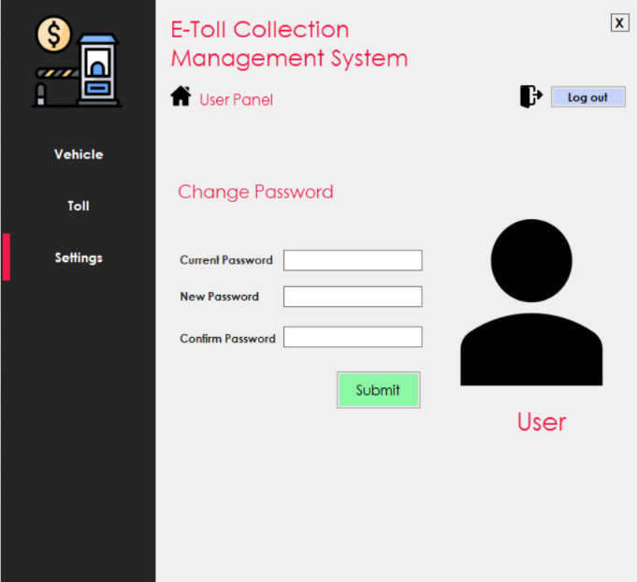

Figure: User Panel (Settings)

|  |  |
| --- | --- |
| Figure: Admin Panel (Toll List) | Figure: Admin Panel (User List) |

|  |
| --- |
| Figure: Manager Panel (Toll Management) |
| Figure: Manager Panel (Transaction) |

# FEATURES NOT TO BE TESTED

We have a total of 10 features in our project. Out of these ten features, three will not be tested. Those three features are:

**Digital Recharge:** As of the first deployment, the digital recharge will not be that much of a concern. Users can load their accounts with sufficient money from Government Banks. So, this is not our first concern.

**Profile Edit:** All the vital information will be cross-checked at the time of registration. So, this is not an essential feature. There will be some functions in profile edit like upload & change the user’s profile picture and change the app’s theme. Without these things, one can easily use the app.

**Multi-language:** By default, the language will be English. We have conducted a survey, most of the participants preferred English as their preferred language for the app. In this way, foreigners can also use the app. Nevertheless, many people preferred Bangla as the app language, so that we will work on that. However, this is not a high-prioritized feature. We will not test this feature as of now.

# TESTING APPROACH

## Testing Levels

The ‘E-Toll Collection System’ testing will consist of Unit, System, Integration, and Acceptance test levels. However, with the budget constraints and timeline established, most testing will be done by the test manager with the development teams’ participation.

* **Unit Testing:** Unit testing means individual testing, and it is also white box testing. When a developer completes a module, the developer compiles that module to ensure the module is working. In our system, this testing will occur when a developer completes the design of any page.
* **System Testing:** This testing occurs when the integration testing has been done. Here it tests the overall system operations as a whole, typically from a customer’s perspective. It is black-box testing. In our system, the tester team will combine the whole system (software and hardware). Then compile the entire system, and if they got any problem, they would fix it as soon as possible.
* **Acceptance Testing:** It is formal testing. This testing phase verifies the entire illness of the customer’s requirement. The Customer/end-user will test the whole system and will give feedback.

## Test Tools

The tools have different approaches to testing and thus have different sets of features. We will use C# and MySQL to develop our software.

### Unit Testing

Unit testing is a type of testing in which individual units or functions of software testing. Its primary purpose is to test each unit or function. A unit is the smallest testable part of an application. It mainly has one or a few inputs and produces a single output.

* For C#, we must need XUnit as a software testing tool.
* For MySQL, we will go with the integrated testing tool with the Microsoft SQL Server.

### System Testing

System testing verifies that an application performs tasks as designed. This step, a kind of black-box testing, focuses on the functionality of an application. System testing, for example, might check that every type of user input produces the intended output across the application.

To perform System testing, we will use:

* **TestingWhiz:** TestingWhiz is Codeless Automation Testing Tool that provides automated testing solutions to global enterprises and software companies for their Software, Web, Mobile, Database, Cloud, Web Services, and API testing. TestingWhiz Automates executes and manages test cases effortlessly & efficiently.
* **Ranorex:** Ranorex is a powerful tool for test automation. It is a GUI test automation framework used to test web-based, desktop, and mobile applications. Ranorex does not have the scripting language to automate an application. It uses standard programming languages such as VB.NET and C#.

## Meetings

Our entire project duration is 21 months, and the testing phase will take three months. In these three months, we have 12 weeks.

* We will test our modules in the first nine weeks by unit testing, integration testing, & system testing. The whole testing phase will occur in this period by the QA Engineers. If they got any defect, they will solve it and again test the entire module.
* It will take two weeks for a customer or third-party test. In this phase, acceptance testing will occur. They will test the system and give us a review report.
* When we get the review report from the vendor and find any defect, we will look up the review report and analyze how we will solve the fault. It will take one week to solve the problems and go for final testing.
* A general meeting will occur every Thursday at 5:00 PM.

# TEST CASES/ TEST ITEMS

|  |  |  |  |  |  |
| --- | --- | --- | --- | --- | --- |
| Project Name: E-Toll Management System | | | Test Designed by: Dihan, MD. Rafee-uzzaman | | |
| Test Case ID: ETCS_1 | | | Test Designed date: 10th November 2023 | | |
| Test Priority: High | | | Test Executed by: Asha Islam | | |
| Module Name: Login Session | | | Test Execution date: 1st December 2023 | | |
| Test Title: Verify login with valid username and password | | | | | |
| Description: Test application login page | | | | | |
| Precondition: User must have valid username and password | | | | | |
| Test Steps | Test Data | Expected Results | | Actual Results | Status |
| 1. Go to the application 2. Enter username 3. Enter password 4. Click submit | Username: Karim  Password: 321 | Users should log in to the application | | As expected | Pass |
| Post Condition: User is validated with database and successfully logs in to account. The account session details are logged in the database. | | | | | |

|  |  |  |  |  |  |
| --- | --- | --- | --- | --- | --- |
| Project Name: E-Toll Management System | | | Test Designed by: Dihan, MD. Rafee-uzzaman | | |
| Test Case ID: ETCS_2 | | | Test Designed date: 10th November 2023 | | |
| Test Priority: High | | | Test Executed by: Asha Islam | | |
| Module Name: Vehicles information adding a session | | | Test Execution date: 2nd December 2023 | | |
| Test Title: Verify the process of add vehicles information | | | | | |
| Description: Test application vehicles information page | | | | | |
| Precondition: User must have a login to the system | | | | | |
| Test Steps | Test Data | Expected Results | | Actual Results | Status |
| 1. Login to account 2. Enter Brand name 3. Enter vehicles model 4. Enter vehicles number 5. Vehicles type 6. Click submit | Brand name:  Toyota  Vehicle model:  AE-110  Vehicle number:  Satkhira-la-112163  Vehicles type: Car | The user should add the information of the vehicle | | As expected | Pass |
| Post Condition: Vehicles information will be saved into the database. | | | | | |

|  |  |  |  |  |  |
| --- | --- | --- | --- | --- | --- |
| Project Name: E-Toll Management System | | | Test Designed by: Dihan, MD. Rafeeuzzaman | | |
| Test Case ID: ETCS_3 | | | Test Designed date: 12th November 2023 | | |
| Test Priority: High | | | Test Executed by: Billah, Bayezid | | |
| Module Name: Sign up Session | | | Test Execution date: 3rd December 2023 | | |
| Test Title: Verify the signup process for creating a new account. | | | | | |
| Description: Test application Sign up page | | | | | |
| Precondition: Check that there is a login page in my application | | | | | |
| Test Steps | Test Data | Expected Results | | Actual Results | Status |
| 1. Go to the signup page 2. Enter Name, Password, confirm password, Full name, phone no, Date of birth 3. Click on Sign Up | Username: NAYIM  Password: 123  Confirm password: 123  Phone no:  01718778776  Date of birth: 19/02/1999 | The user should create a new account. | | As expected | Pass |
| Post Condition: The user information will be inserted into the database. | | | | | |

|  |  |  |  |  |  |
| --- | --- | --- | --- | --- | --- |
| Project Name: E-Toll Management System | | | Test Designed by: Dihan, MD. Rafeeuzzaman | | |
| Test Case ID: ETCS_4 | | | Test Designed date: 14th November 2023 | | |
| Test Priority: Medium | | | Test Executed by: Billah, Bayezid | | |
| Module Name: Vehicle Search Session | | | Test Execution date: 5th December 2023 | | |
| Test Title: Verify vehicle search process | | | | | |
| Description: Test application vehicles information page. | | | | | |
| Precondition: User must have to log in to account | | | | | |
| Test Steps | Test Data | Expected Results | | Actual Results | Status |
| 1. Go to application 2. Enter vehicle name 3. Click on Search | Vehicle name:  AE-110 | The user should see the details of the vehicle | | As expected | Pass |
| Post Condition: This process will search the details information into the system database for the typed vehicle name. | | | | | |

|  |  |  |  |  |  |
| --- | --- | --- | --- | --- | --- |
| Project Name: E-Toll Management System | | | Test Designed by: Dihan, MD. Rafeeuzzaman | | |
| Test Case ID: ETCS_5 | | | Test Designed date: 17th November 2023 | | |
| Test Priority: High | | | Test Executed by: Md Rayhan Talukder | | |
| Module Name: Toll Pay Session | | | Test Execution date: 7th December 2023 | | |
| Test Title: Verify the toll-paying process | | | | | |
| Description: Test application toll pay page | | | | | |
| Precondition: User must have a valid account | | | | | |
| Test Steps | Test Data | Expected Results | | Actual Results | Status |
| 1. Login into the application 2. Enter Place Name 3. Enter Vehicle number 4. Click on Pay | Place name: Meghna Bridge  Vehicle Name: AE-110 | Users should be able to pay the toll | | As expected | Pass |
| Post Condition: The information will be updated in the toll information database. | | | | | |

|  |  |  |  |  |  |
| --- | --- | --- | --- | --- | --- |
| Project Name: E-Toll Management System | | | Test Designed by: Dihan, MD. Rafeeuzzaman | | |
| Test Case ID: ETCS_6 | | | Test Designed date: 20th November 2023 | | |
| Test Priority: Medium | | | Test Executed by: Md Rayhan Talukder | | |
| Module Name: Change password Session | | | Test Execution date: 10th December 2023 | | |
| Test Title: Verify password change process | | | | | |
| Description: Test Password Change | | | | | |
| Precondition: User must have to log in to account | | | | | |
| Test Steps | Test Data | Expected Results | | Actual Results | Status |
| 1. Go to the Settings 2. Enter current password 3. Enter password 4. Click submit | Current password:  123  New password: 1122  Confirm password: 1122 | The user should change the password | | As expected | Pass |
| Post Condition: The previous password should be replaced with a new password in the database. | | | | | |

|  |  |  |  |  |  |
| --- | --- | --- | --- | --- | --- |
| Project Name: E-Toll management system | | | Test Designed by: Dihan, MD. Rafeeuzzaman | | |
| Test Case ID: ETCS_7 | | | Test Designed date: 25th November 2023 | | |
| Test Priority: Medium | | | Test Executed by: Dihan, MD. Rafee-uzzaman | | |
| Module Name: See User List Session | | | Test Execution date: 18th December 2023 | | |
| Test Title: Verify user information showing | | | | | |
| Description: Test application admin panel | | | | | |
| Precondition: User must have a login to the application as an admin | | | | | |
| Test Steps | Test Data | Expected Results | | Actual Results | Status |
| 1. Go to the User Page 2. Enter username 3. Click on Search | Username: Karim | Admin should see the user information | | As expected | Pass |
| Post Condition: This process will search the details information into the system database for the typed username. | | | | | |

# ITEM PASS/ FAIL CRITERIA

Whether an item has passed or failed will be evaluated in 3 ways.

1. **Evaluation team:** Evaluation team will look after each Items condition. In this subsection, by whom the items will be checked are:

* UAT (User Acceptance Testing) Manager
* UAT Analyst
* Project Sponsor
* A representative of the Development Team

1. **Exit Criteria:** In this subsection, the following conditions will be checked:

* All code completed and frozen, and no modules to be integrated.
* 100% system integration tests passed
* No major defect is found.
* All the moderate defects found in SIT (System Integration Testing) phase have been fixed and re-tested.
* Not more than 25 minor defects are outstanding.
* Two weeks system uptime in system integration test environment without any anomalies.
* System integration tests are documented.

1. **Evaluation Process:** This sub-section on the Evaluation Process describes a four-stage process for systematically evaluating the testing results to decide whether the test item has passed or failed. The stages are:

* **Summarize Testing Results**: All open or closed incidents will be traced to a Requirements Traceability Matrix requirement.
* **Evaluate Business Scenarios:** Each open Incident - and closed Incident, if agreed it is appropriate - is traced back to the Business Scenarios. An assessment is made about the technical impact and whether they can deliver the functionality the organization needs.
* **Estimate Business Impact:** Each open Incident is then checked to see its impact on the organization. The effect, frequency of business impact, and countermeasures such as fix schedule and workarounds are analyzed and recorded.
* **Make Acceptance Decision:** The analyses are then evaluated as to the acceptance decision. This acceptance can be one of:
* **Full Acceptance:** The system will be accepted as is. Any outstanding Incidents will be worked around.
* **Limited System Acceptance:** The outstanding Incidents cause too many problems. The system is accepted subject to a timetable of fixes, staff training about workarounds, and similar measures.
* **System Rejection:** This is where the system does not support the Business Scenarios of the organization.

# TEST DELIVERABLES

* Test Plan: This document deals with what needs to be done in UAT.
* Designs: The UAT Acceptance Criteria.
* Test Cases: The values input and results expected from tests.
* Test Item Transmittal Reports: Developers handover report.
* Test Logs: The results of running the tests.
* Incident Reports: Observations of unexpected results.
* Incident Report Logs: Summary of Incident Reports.
* Test Summary Report: Summary of testing.
* The test data.

# STAFFING AND TRAINING NEEDS

* The developers and testers will need to be trained on the basic operations of the EDI interface. Before final acceptance of the project, the operations staff will also require complete training on the EDI communications process.
* The sales administration staff will require training on the new screens and reports.
* At least one developer and operations staff member must be trained on the PC-based distributors EDI package’s installation and control. The distributor’s personnel will also have to be trained on the PC-based package and its operational characteristics.

# RESPONSIBILITIES

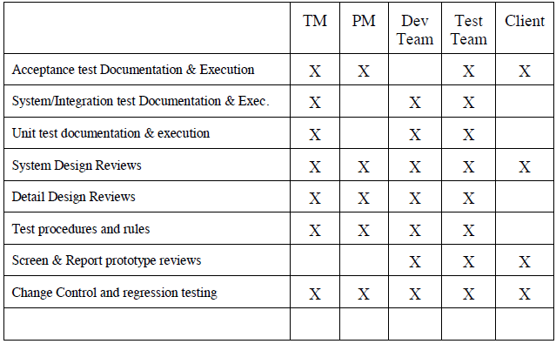

# TESTING SCHEDULE

The following testing activities have been scheduled in the project plan. The project plan timetable specifies the particular dates and hours for each task. The people who are needed for each procedure are also listed in the project timeline and plan. In collaboration with the development and test team leaders, the project manager will coordinate the employees required for each task, test team, development team, management, and customer.

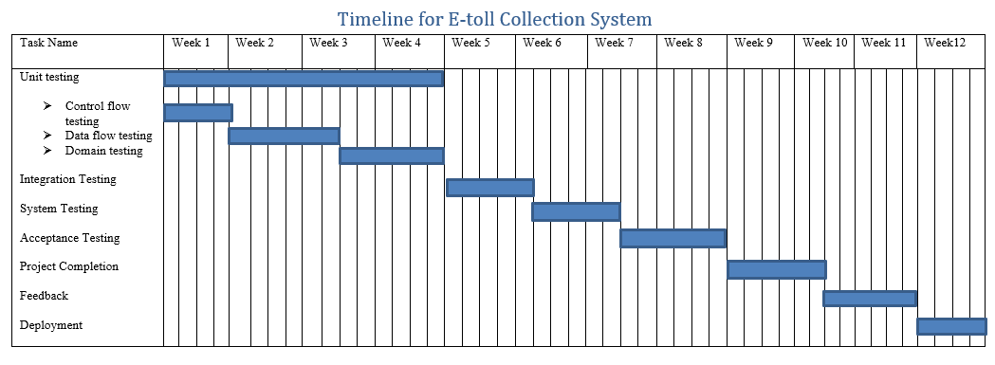

# PLANNING RISKS AND CONTINGENCIES

|  |  |  |  |
| --- | --- | --- | --- |
| Risk | Probability | Impact | Mitigation |
| Error in Functions | Medium | Medium | Test the application frequently and maintain a daily backup. |
| Wrong SQL Command for Important Data | Medium | High | Maintain security checks & backups. |
| Loss of encrypted data | Medium | High | Maintain security check and backup. |
| User’s account hacking attempt | High | High | Restrict user after three unsuccessful login attempts in an hour. |